Embellishments
January 2021
stjohnsguildofembroiderers.com
eac-acb.ca

Happy New Year

**Please note the change of venue**

Dates to Remember:
Jan: 26th: Monthly Meeting
Jan. 31th: Deadline to apply for the Hannalore Walter Scholarship. Go to the website for more information.
Feb. 13th: Caribou Tufting workshop with Susan Furneaux.

January Meeting: The January meeting will be held on Jan. 26th, 7:30 pm at the Knights of Columbus on St. Clare Avenue. We will be using the upstairs room. Corpus Christie Hall was not available to us as they had an opportunity to rent the hall for a full month.

We will be you adhering to the Covid-19 rules listed below.
Please make note of the following:

- Only 40 people are allowed to attend.
- You must wear a mask until you are seated.
- You must maintain social distancing.
- If you would like tea or coffee, please provide your own.
- It will be first come, first served.

Programs:

The program for January to March will be a wonderful canvas piece called Summer Fireworks by Ann-Marie Anderson Moyes. This is one of the free pieces from her
website: http://beautifulstitches.com.au/free-patterns/

This is a stash buster piece in that you can use threads from your stash. You will need:
- 1 skein of wildflower or variegated perle thread
- 1 skein of 4 contrasting/complimentary colours of 6-strand cotton.

Stretcher bars in sizes 8 x 12

The kit supplied by the Guild will contain colour photocopies of the instructions and congress cloth.

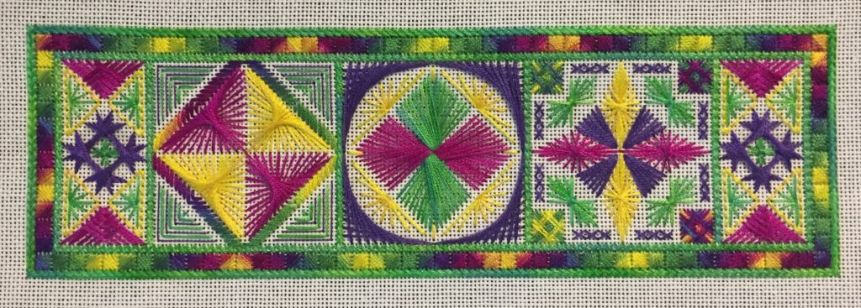
Workshops:
a. Beaded Star: Corinne has volunteered to teach a small beaded star ornament sometime in the spring. Cost $25.00. Marg Adey will have a sign-up sheet at the monthly meeting.

b. Caribou Tufting: Susan Furneaux is offering a caribou-tufting workshop on February 13th. Cost $25.00. There is still to sign up to learn this most intriguing technique. As per usual, the photo does not show the beauty of this piece.

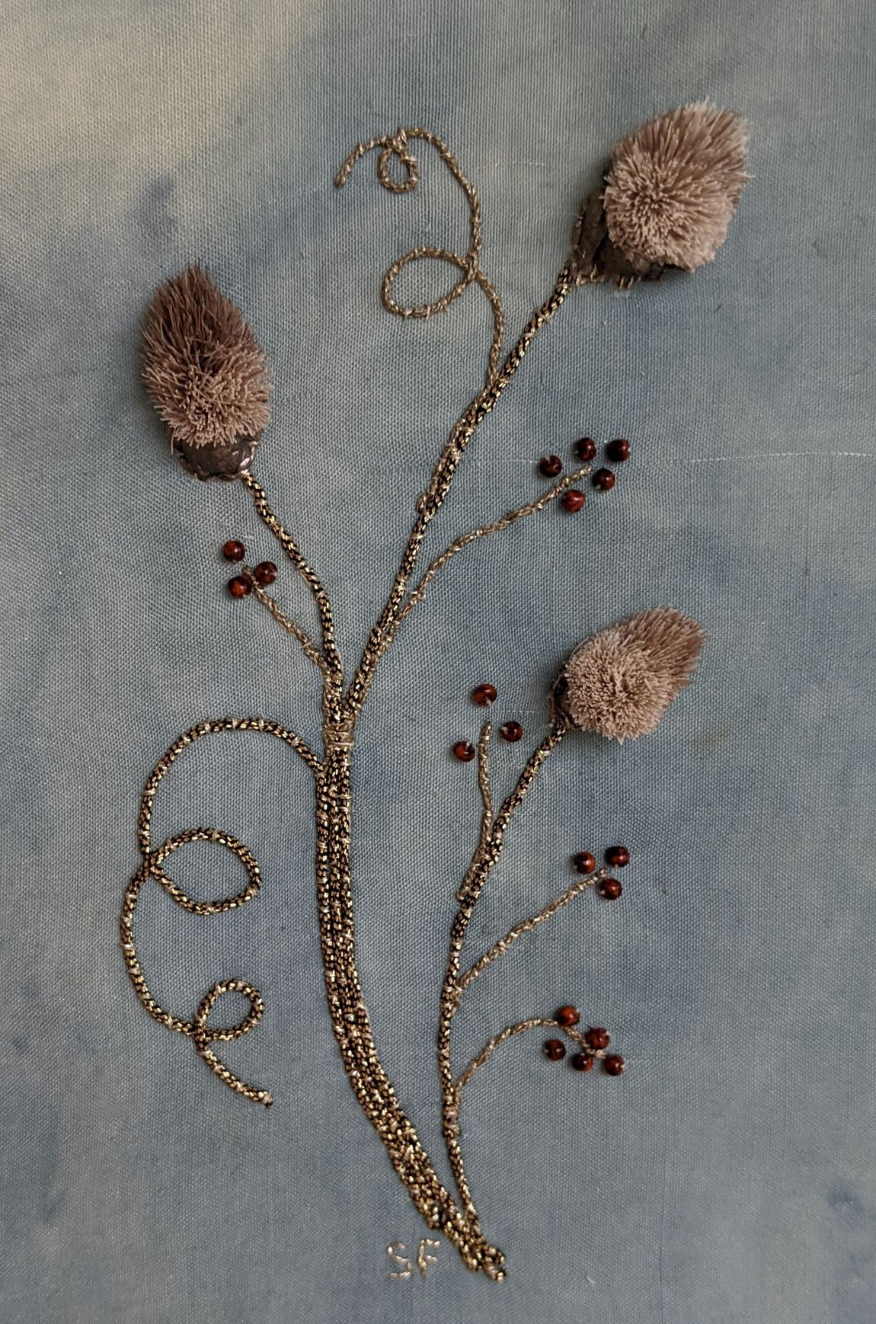

.

Workshop Report:
Jane Prior: Stumpwork, October 17th and November 25th.
Income
 | Fees: 14 x $50 | $700.00
Expenses: | Teaching Fee: $150 x 2 | $300.00
 | Kit Fees: $25.00 x 15 | $375.00
 | Travel: 2 return trips | $168.00
 | Meals: 2 x $12 | $24.00
 | Room Rental | $150.00
 | Total Expenses | $1017.00
Cost to Guild: $317.00

Teaching Opportunity Seminar 2022
A letter from Barb Crowther <2022teachers@eac-acb.ca>
Good day,
I am the workshop co-ordinator for Seminar 2022 to be held during May (2022) somewhere in the Toronto GTA. While not all the details have been finalized, I have been very busy looking for instructors.

If any of your members have any interest in leading a workshop, could they please send me an email at this address? I will be sure that they are sent the appropriate information when it becomes available.

Remember, just because you are expressing an interest, doesn’t mean you are committing

Many thanks: Barb Crowther

Embellishments composed by Gillian

